**List of Stakeholders**  
**1. Internal Stakeholders:**

a. Executive Management:

CEO & Board of Directors: Oversee the strategic direction and success of the ABC Pantry initiative.

Chief Financial Officer (CFO): Monitors the financial performance and budget allocation for the project.

Chief Operating Officer (COO): Ensures that operational aspects of ABC Pantry align with the company’s broader operational goals.

b. Project Management Team:

Project Manager: Oversees the planning, execution, and completion of the ABC Pantry project.

Business Analysts: Capture requirements, analyze data, and ensure that the new feature meets business needs.

Product Owners: Define the product vision and prioritize features to be developed.

c. Development Team:

Software Developers: Implement the ABC Pantry feature on the website/app.

UI/UX Designers: Design the user interface and experience for ABC Pantry.

Quality Assurance (QA) Team: Test the new feature to ensure it is free of bugs and meets the specified requirements.

d. Sales and Marketing:

Marketing Managers: Develop marketing strategies to promote ABC Pantry.

Sales Teams: Leverage existing sales channels to push the new product feature.

e. Customer Support:

Customer Service Representatives: Handle inquiries and issues related to ABC Pantry from customers.

Technical Support: Provide backend support for technical issues related to the new feature.

f. Logistics and Supply Chain:

Supply Chain Managers: Ensure the availability and timely delivery of products listed under ABC Pantry.

Warehouse Managers: Manage the storage and dispatch of daily essential products.

2. External Stakeholders:

a. Customers:

Existing Customers: Current users of ABC Company’s website/app who will use the ABC Pantry feature.

Potential New Customers: Individuals who might be attracted to the platform due to the addition of daily essential products.

b. Suppliers and Vendors:

Product Suppliers: Providers of daily essential products such as cereals, snacks, beverages, etc.

Logistics Providers: Companies responsible for the transportation and delivery of the products.

c. Regulatory Bodies:

Government Agencies: Ensure that the business complies with local, state, and federal regulations related to e-commerce and retail.

Health and Safety Regulators: Oversee the compliance with health and safety standards for food and daily essential products.

d. Advertising Partners:

Advertisers: Companies that will advertise on the ABC Pantry platform.

Advertising Agencies: Create and manage advertisements for products listed on ABC Pantry.

3. Other Stakeholders:

a. Competitors:

Other E-commerce Platforms: Monitor the competitive landscape to understand the impact of ABC Pantry on market dynamics.

b. Investors and Shareholders:

Investors: Monitor the financial performance and strategic direction of ABC Company.

Shareholders: Interested in the profitability and market expansion of ABC Company through the new feature.

c. Media and Analysts:

Industry Analysts: Provide analysis and insights on the impact of ABC Pantry on the e-commerce market.

Media Outlets: Cover news and updates related to ABC Company's new initiatives.

**As-in- Process**

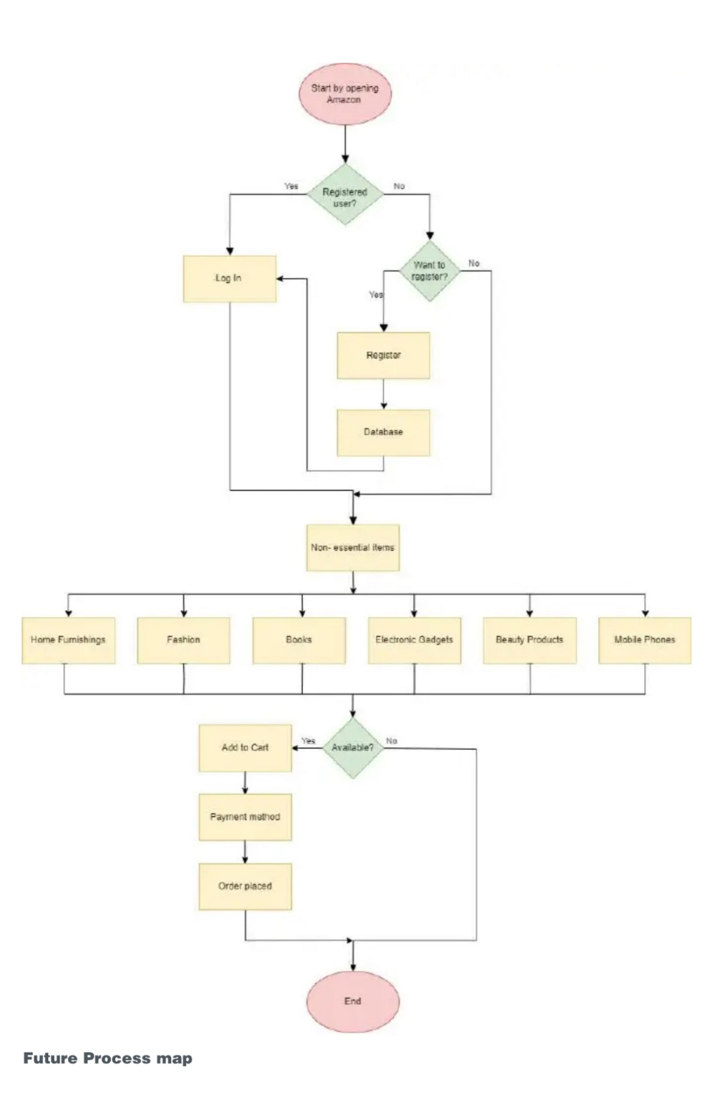  
  
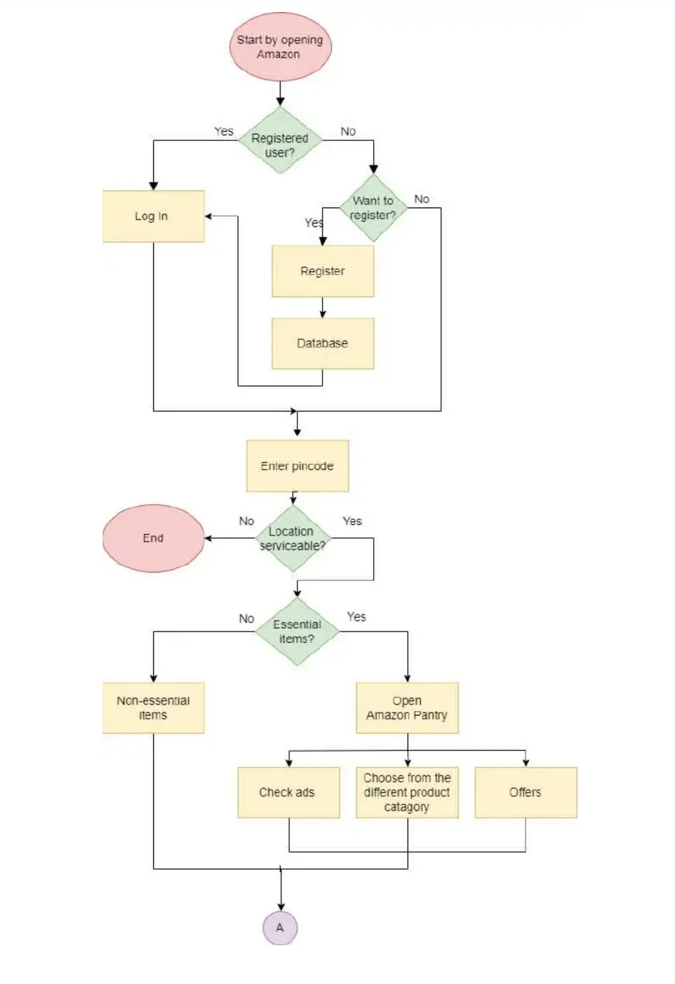  
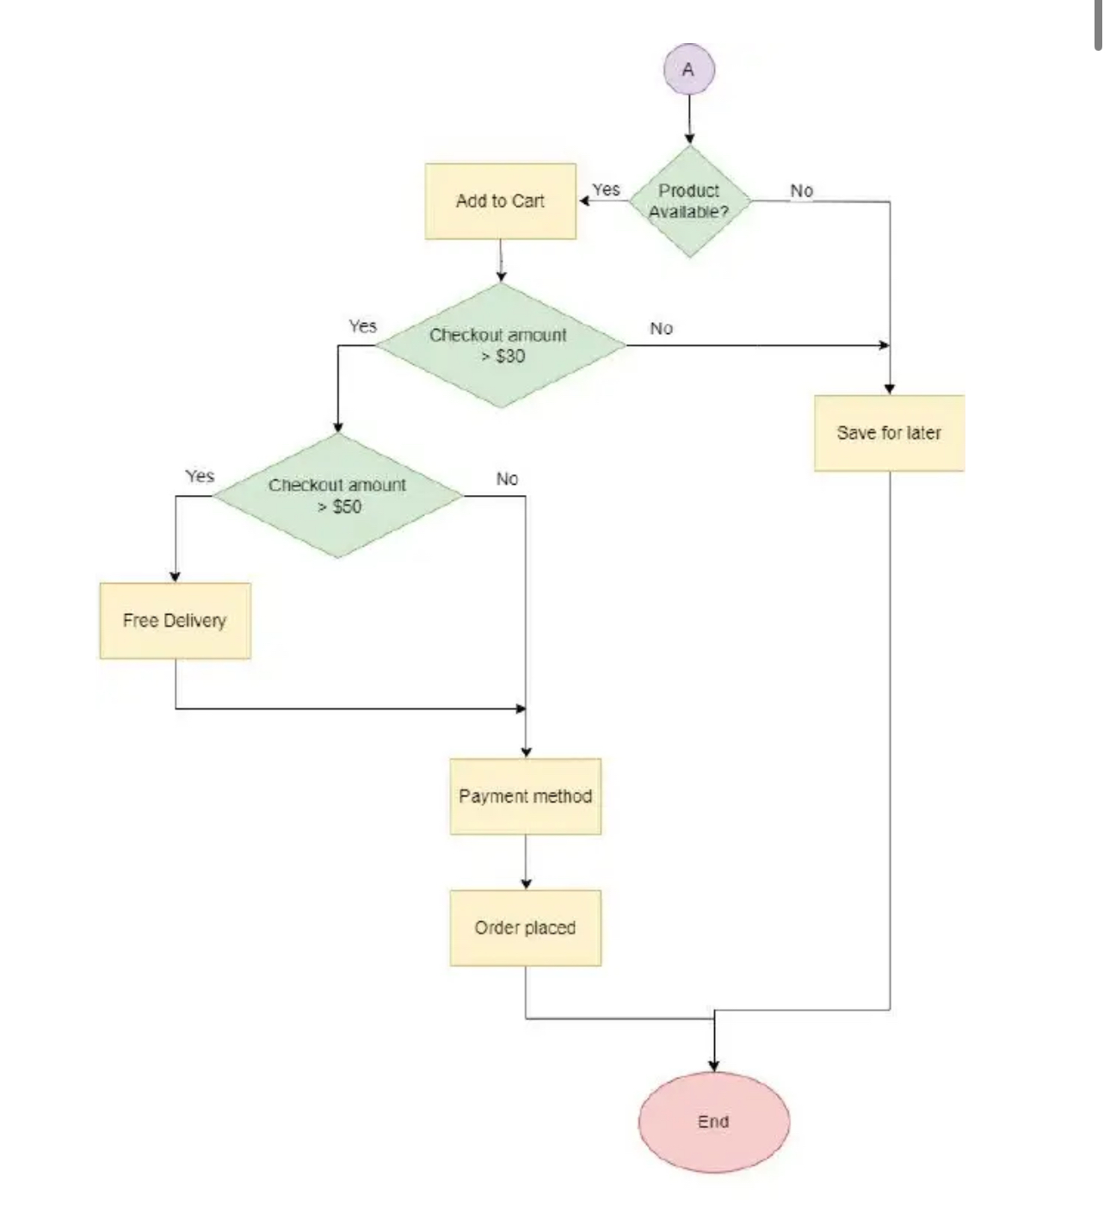

**Main Features to be developed**

1. ABC Pantry Integration:

Prominent Display: Ensure ABC Pantry is prominently displayed on the homepage and within the app to attract user attention.

Dedicated Section: Create a dedicated section for ABC Pantry that users can easily navigate to.

2. Product Categories:

Logical Grouping: Develop a logical grouping of daily essential products for easy navigation and search ability.

Categories Include:

Flour and rice

Sugar, salt, and spices

Pulses

Personal care

Snacks

Hand wash and sanitizers

Household cleaning essentials

Breakfast food items

Tea and coffee

Baby care

Female hygiene

Tissues and fresheners

3. Advertisements:

Non-Intrusive Ads: Implement up to five advertisements within the ABC Pantry section. Ensure these ads are strategically placed to not hinder the user experience.

4. Special Offers:

Offer Display: Feature special offers within the ABC Pantry to attract customers.

Highlight Deals: Highlight time-sensitive deals and discounts prominently.

5. Shopping Cart Integration:

Unified Cart: Ensure that items from ABC Pantry can be added to the same shopping cart as non-essential items.

Order Amount Validation: Implement a check to ensure the total order amount exceeds 30 USD before allowing checkout.

6. Delivery Conditions:

Minimum Order Value: Enforce a minimum order value of 30 USD.

Free Delivery Threshold: Offer free delivery for orders exceeding 50 USD.

City-Specific Availability: Limit ABC Pantry services to specific cities as defined in the data sets.

7. User Experience:

Seamless Navigation: Ensure easy navigation between ABC Pantry and other sections of the website/app.

Search Functionality: Enhance search functionality to include filters specific to daily essential products.

Mobile Optimization: Ensure the ABC Pantry feature is optimized for mobile devices.

8. Reporting and Analytics:

Sales Reports: Generate daily sales reports including:

Total sales for each day

Total sales per product category

Total sales across the USA

Total sales for each city

Total sales per zone (zone 1, 2, 3, 4)

Best-selling categories

Worst-selling categories

Weekly sales city-wise

Highest booking day of the week

Performance Metrics: Track user engagement and sales performance for ABC Pantry.

9. Customer Account Integration:

Order History: Allow users to view ABC Pantry orders in their account order history.

Subscription Options: Develop subscription options for regular delivery of certain daily essentials.  
  
  
**In-Scope Items**

The following features and functionalities are included in the scope of the ABC Pantry software enhancement project:

1. ABC Pantry Integration:

Prominently display ABC Pantry on the homepage and within the app.

Create a dedicated section for ABC Pantry with easy navigation.

2. Product Categories:

Develop logical grouping for daily essential products.

Include the following categories:

Flour and rice

Sugar, salt, and spices

Pulses

Personal care

Snacks

Hand wash and sanitizers

Household cleaning essentials

Breakfast food items

Tea and coffee

Baby care

Female hygiene

Tissues and fresheners

3. Advertisements:

Implement up to five non-intrusive advertisements within the ABC Pantry section.

4. Special Offers:

Feature special offers within ABC Pantry.

Highlight time-sensitive deals and discounts.

5. Shopping Cart Integration:

Ensure items from ABC Pantry can be added to the same shopping cart as non-essential items.

Implement a check to ensure the total order amount exceeds 30 USD before checkout.

6. Delivery Conditions:

Enforce a minimum order value of 30 USD.

Offer free delivery for orders exceeding 50 USD.

Limit ABC Pantry services to specific cities as defined in the data sets.

7. User Experience:

Ensure seamless navigation between ABC Pantry and other sections.

Enhance search functionality to include filters specific to daily essential products.

Optimize the ABC Pantry feature for mobile devices.

8. Reporting and Analytics:

Generate daily sales reports including:

Total sales for each day

Total sales per product category

Total sales across the USA

Total sales for each city

Total sales per zone (zone 1, 2, 3, 4)

Best-selling categories

Worst-selling categories

Weekly sales city-wise

Highest booking day of the week

Track user engagement and sales performance for ABC Pantry.

9. Customer Account Integration:

Allow users to view ABC Pantry orders in their account order history.

Develop subscription options for regular delivery of certain daily essentials.

**Out-of-Scope Items**

The following features and functionalities are excluded from the scope of the ABC Pantry software enhancement project:

1. International Expansion:

Expansion to markets outside the specified cities in the data set.

2. Payment Methods:

Development of new payment methods beyond the existing options.

3. Major Redesign:

Major redesign of the existing website/app unrelated to the ABC Pantry feature.

4. New Product Categories:

Inclusion of new product categories outside the specified daily essentials.

5. Third-Party Integrations:

Integration with third-party services or platforms not currently used by ABC Company.

6. Advanced AI Features:

Implementation of advanced AI-driven personalization or recommendation systems beyond the current capabilities.

7. Customer Loyalty Programs:

Development of new customer loyalty or reward programs specific to ABC Pantry.

8. Offline Store Integration:

Integration with physical stores or offline purchase options.

9. Long-term Logistics Enhancements:

Major overhauls or enhancements to logistics and supply chain management beyond supporting ABC Pantry deliveries.

10. Non-Daily Essential Products:

Inclusion of non-daily essential products within the ABC Pantry feature.  
  
**Business Requirements for ABC Pantry**

**Functional Requirements**

ABC Pantry Integration:

Homepage Display: ABC Pantry must be prominently displayed on the homepage of the website and app.

Dedicated Section: Create a dedicated section for ABC Pantry within the website and app.

Product Categories:

Category Grouping: Products must be logically grouped under the following categories:

Flour and rice

Sugar, salt, and spices

Pulses

Personal care

Snacks

Hand wash and sanitizers

Household cleaning essentials

Breakfast food items

Tea and coffee

Baby care

Female hygiene

Tissues and fresheners

Product Listings:

Product Details: Each product must have a detailed listing including name, description, price, and availability.

Product Images: Include high-quality images for each product.

Advertisements:

Ad Slots: Implement up to five advertisements within the ABC Pantry section.

Placement: Ensure advertisements are placed non-intrusively.

Special Offers:

Offer Display: Display special offers and discounts within the ABC Pantry section.

Highlight Deals: Highlight time-sensitive deals prominently.

Shopping Cart Integration:

Unified Cart: Allow items from ABC Pantry to be added to the same shopping cart as non-essential items.

Order Amount Check: Implement a validation to ensure the total order amount exceeds 30 USD before allowing checkout.

Delivery Conditions:

Minimum Order Value: Enforce a minimum order value of 30 USD.

Free Delivery Threshold: Offer free delivery for orders exceeding 50 USD.

City-Specific Service: Limit ABC Pantry service to specific cities as defined in the data sets.

User Experience:

Navigation: Ensure seamless navigation between ABC Pantry and other sections.

Search Filters: Enhance search functionality to include filters specific to daily essential products.

Mobile Optimization: Optimize the ABC Pantry feature for mobile devices.

Customer Account Integration:

Order History: Allow users to view ABC Pantry orders in their account order history.

Subscription Options: Develop subscription options for regular delivery of certain daily essentials.

Reporting and Analytics:

Sales Reports: Generate daily sales reports including:

Total sales for each day

Total sales per product category

Total sales across the USA

Total sales for each city

Total sales per zone (zone 1, 2, 3, 4)

Best-selling categories

Worst-selling categories

Weekly sales city-wise

Highest booking day of the week

Performance Tracking: Track user engagement and sales performance for ABC Pantry.

**Non-Functional Requirements**

Performance:

Response Time: The system must respond to user actions within 2 seconds.

Load Handling: The system should handle up to 10,000 concurrent users without performance degradation.

Scalability:

Future Growth: The system must be scalable to accommodate future growth in users and product listings.

Availability:

Uptime: The system should have an uptime of 99.9% to ensure continuous availability.

Security:

Data Protection: User data must be protected with encryption both in transit and at rest.

Access Control: Implement strict access control measures to ensure only authorized personnel can access sensitive data.

Usability:

User-Friendly Interface: The system should have a user-friendly interface that is easy to navigate for all users.

Accessibility: The system should be accessible to users with disabilities, complying with WCAG 2.1 guidelines.

Compatibility:

Cross-Platform Support: The system must be compatible with major web browsers (Chrome, Firefox, Safari, and Edge) and mobile operating systems (iOS, Android).

Reliability:

Error Handling: The system should gracefully handle errors and provide meaningful messages to the user.

Data Integrity: Ensure data integrity during transactions to prevent data loss or corruption.

Maintainability:

Code Quality: The system should be built with high-quality, maintainable code following best practices.

Documentation: Comprehensive documentation should be provided for both users and developers.

Compliance:

Regulatory Compliance: The system must comply with relevant regulations such as GDPR, CCPA, and local e-commerce laws.

Health and Safety Standards: Ensure compliance with health and safety standards for food and daily essential products.

Backup and Recovery:

Data Backup: Implement regular data backups to prevent data loss.

Disaster Recovery: Develop a disaster recovery plan to ensure business continuity in case of a major incident.

**Draw wireframes or mock screens for two of the features namely menu creation and table reservation. Use the technique prototyping or wireframing that is taught in the training. You can use any of the wireframing tools like Microsoft PowerPoint, Microsoft Word, Balsamiq, Sketch, Adobe XD, Adobe ILLustrator, Figma, UXPin, InVision Studio, Invision Freehand, or Moqups.**

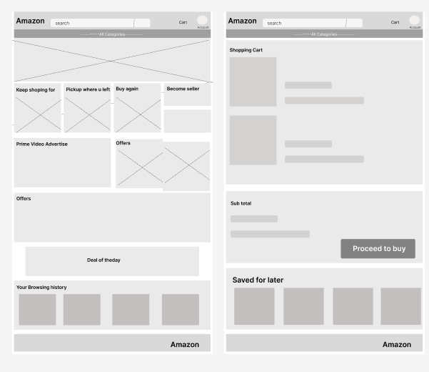

**Make a product backlog of user stories for the given case study. User Stories should be in the format of as a <type of user>, I want <goal> so that <reason>**

**For each story, write the acceptance criteria.**

**ABC Pantry Homepage Section**

User Story 1: Display ABC Pantry on Homepage

As a customer, I want ABC Pantry to be prominently displayed on the homepage so that I can easily access daily essential products.

Acceptance Criteria:

ABC Pantry section is visible on the homepage.

Clicking on the ABC Pantry section navigates to the ABC Pantry page.

2. Product Categories

User Story 2: View Product Categories

As a customer, I want to see categories of daily essential products so that I can easily find the items I need.

Acceptance Criteria:

Product categories are displayed within the ABC Pantry section.

Each category is clickable and navigates to the respective product listing page.

User Story 3: Browse Specific Category

As a customer, I want to browse products within a specific category (e.g., Snacks) so that I can find the products I am looking for.

Acceptance Criteria:

Category pages display a list of products belonging to that category.

Each product listing includes an image, name, price, and add to cart button.

3. Shopping Cart Integration

User Story 4: Add Product to Cart

As a customer, I want to add a product to my shopping cart so that I can purchase it along with other items.

Acceptance Criteria:

Add to cart button is available on product listings and detail pages.

Clicking add to cart updates the shopping cart with the selected item.

User Story 5: Unified Shopping Cart

As a customer, I want to add products from ABC Pantry to my existing shopping cart so that I can purchase both essential and non-essential items in one transaction.

Acceptance Criteria:

ABC Pantry products can be added to the same shopping cart as other products.

Shopping cart displays items from all categories.

4. Delivery Conditions

User Story 6: Minimum Order Validation

As a customer, I want the system to validate that my total order amount is at least 30 USD so that I can proceed to checkout.

Acceptance Criteria:

System checks the total order amount at checkout.

Error message is displayed if the total order amount is less than 30 USD.

User Story 7: Free Delivery for Orders Over 50 USD

As a customer, I want to receive free delivery if my order exceeds 50 USD so that I can save on shipping costs.

Acceptance Criteria:

Free delivery option is available for orders over 50 USD.

Delivery charges are calculated based on the order value.

5. Reporting and Analytics

User Story 8: Daily Sales Report

As a business analyst, I want to generate daily sales reports for ABC Pantry so that I can analyze the sales performance.

Acceptance Criteria:

Daily sales reports are generated automatically.

Reports include total sales and number of orders.

User Story 9: Category Sales Report

As a business analyst, I want to generate sales reports for each product category so that I can identify best-selling and worst-selling categories.

Acceptance Criteria:

Category sales reports include total sales and number of items sold per category.

Reports highlight best-selling and worst-selling categories.

**Create a dashboard for senior management for Chicago to view sales of personal care products for the last 6 months. Make assumptions as appropriate and create the dashboard using your own mock data. For any missing data make your assumptions to create mock data. Write down the assumptions as well.**

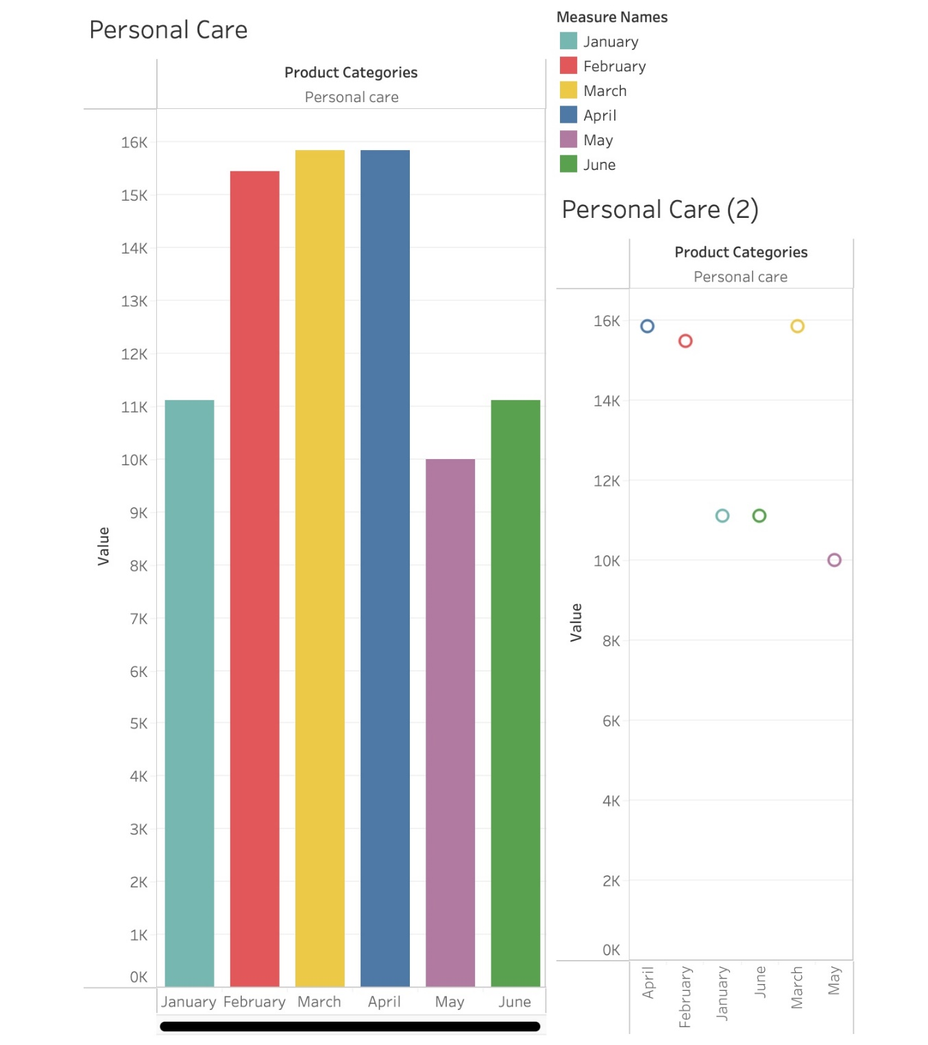

**Create a dashboard to show Senior Management for Chicago to view sales of breakfast products for the last six months. Make assumptions as appropriate and create the dashboard using your own mock data. For any missing data make your assumptions to create mock data. Write down the assumptions as well.**

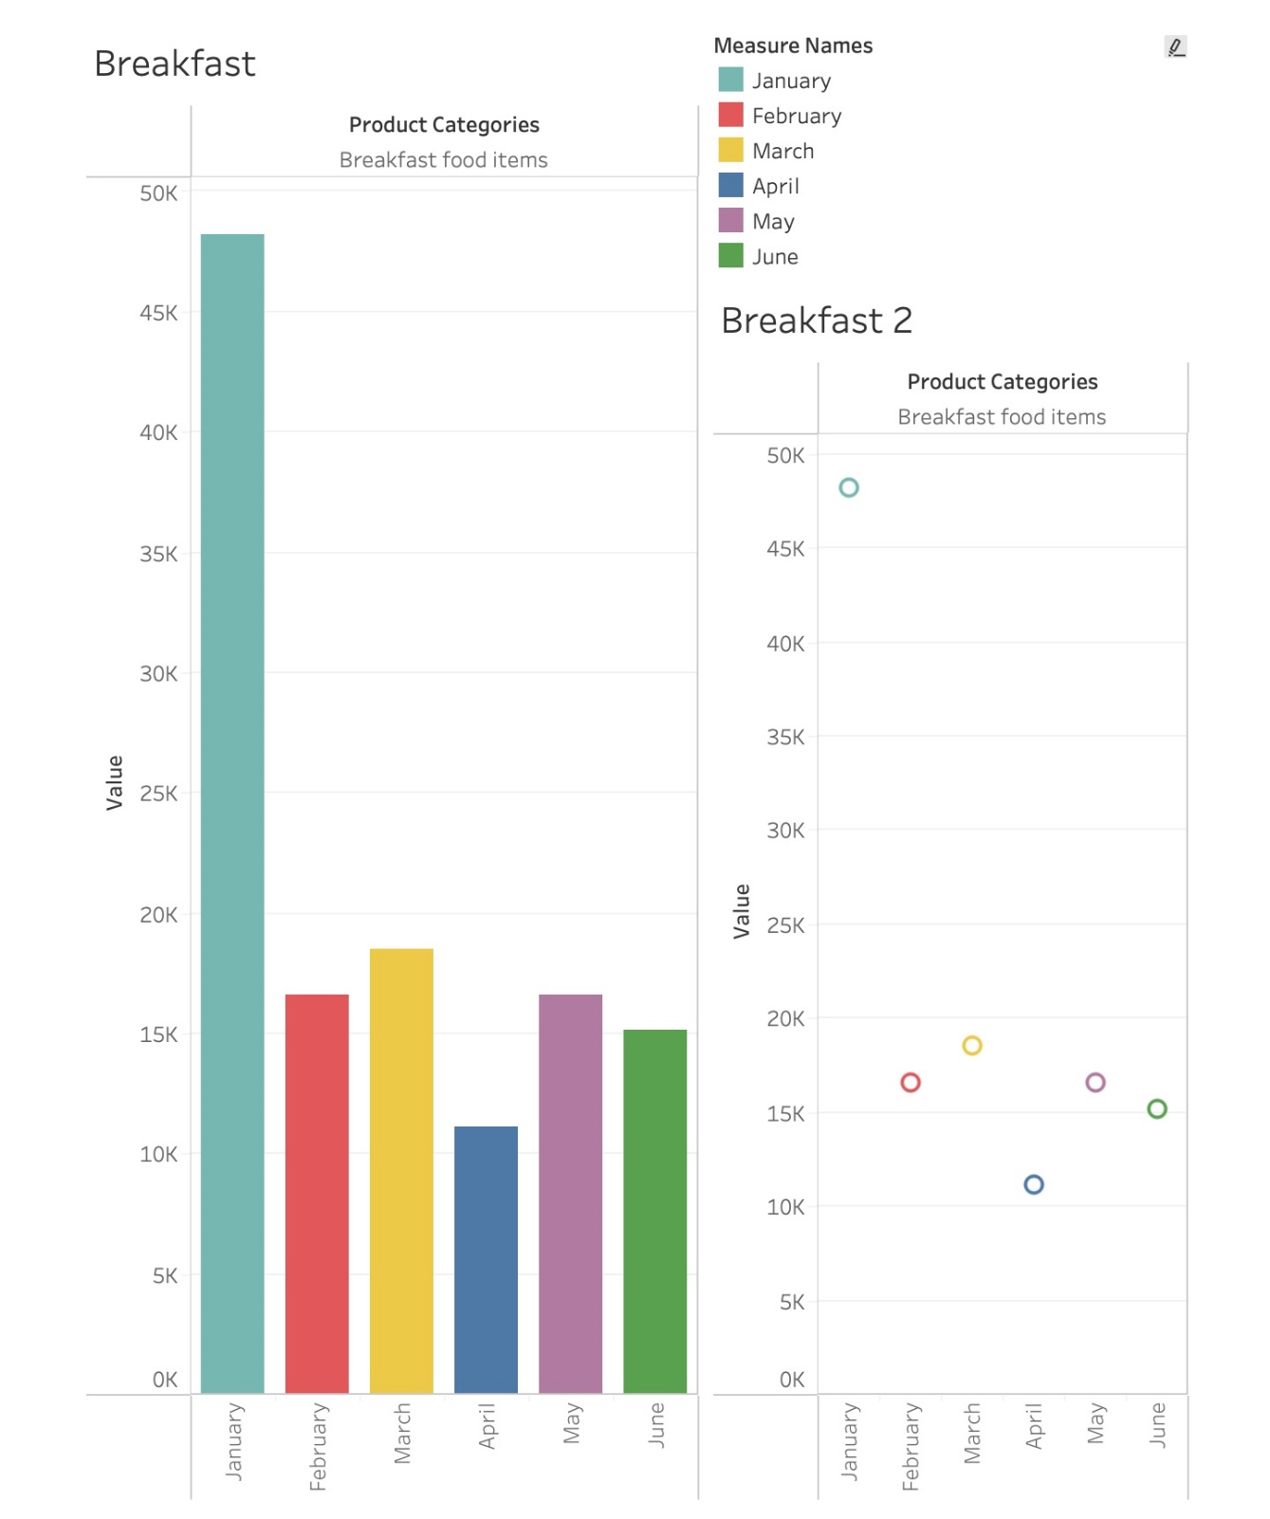

**Create a bar graph showing the sales. Label the chart correctly so that senior management gets a clear report of sales.**

**Arrange the data above in excel in ascending and descending order.**

**Create bar graphs of sales for zone 1 cities**

**Find total sales across all cities**

**Using vlookup for product code HS, find sales in Phoenix**

**Using vlookup for product code FR, find sales in Dallas**  
  
